**PROGRAM – 1**

**Q1:** Write a program to create a basic calculator that can perform addition, subtraction, multiplication, and division. The program should ask for two numbers (floating point) and perform all the operations

**CODE:**

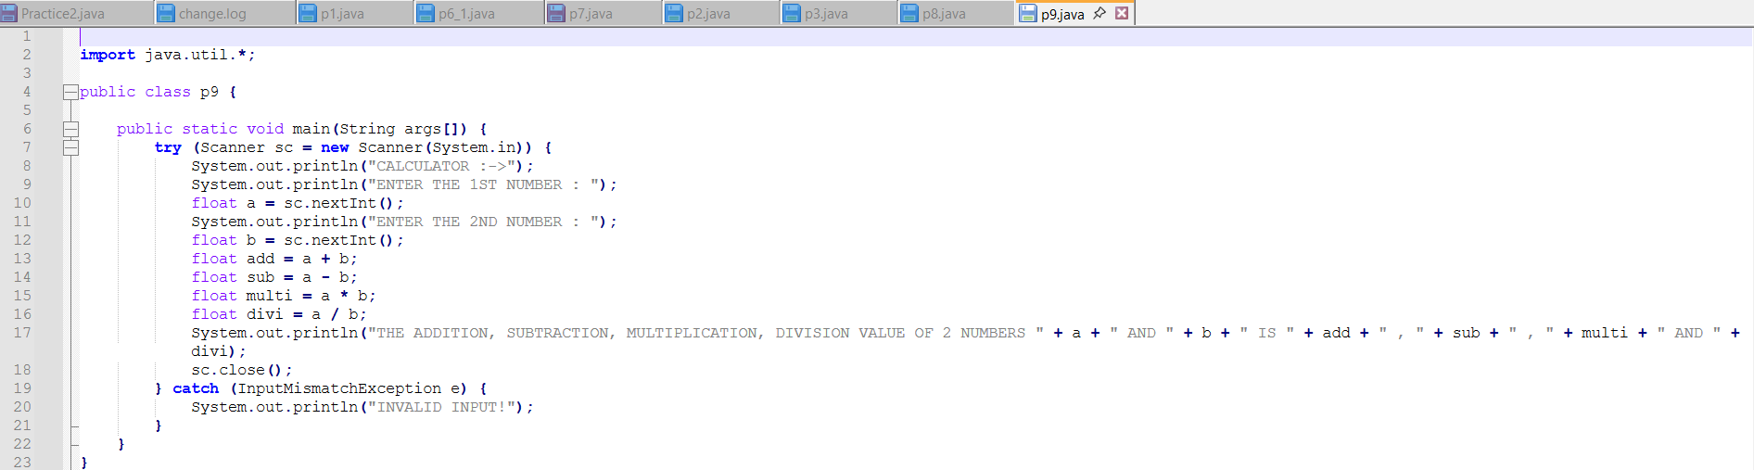

**OUTPUT:**

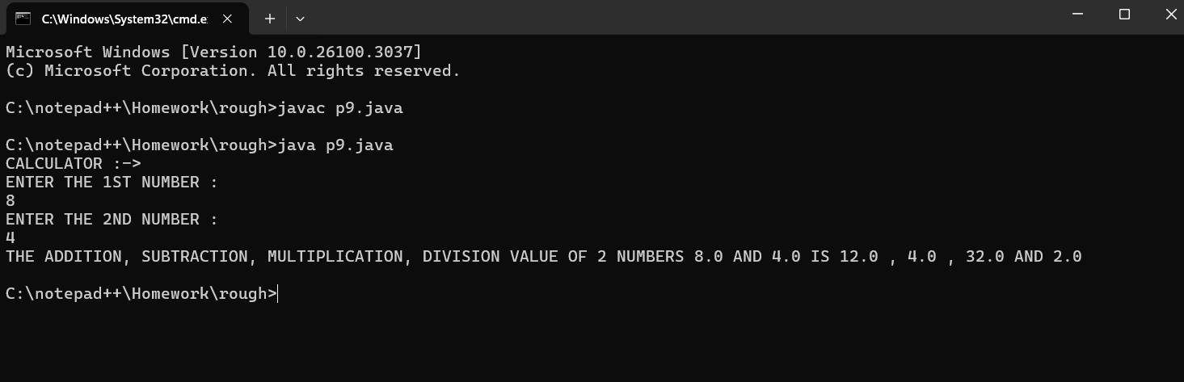

**PROGRAM – 2**

**Q2:** Write a program that takes the base and height to find area of a triangle in square inches and square cm.

**CODE:**

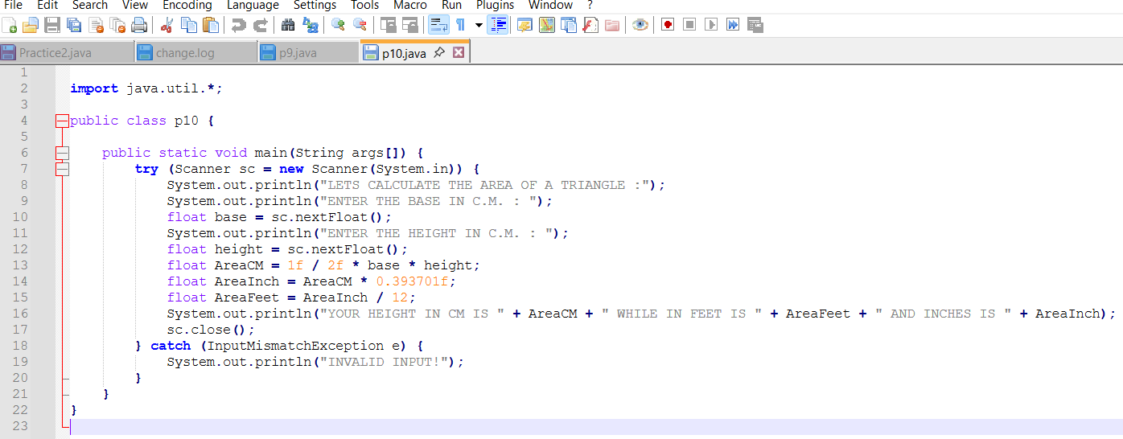

**OUTPUT:**

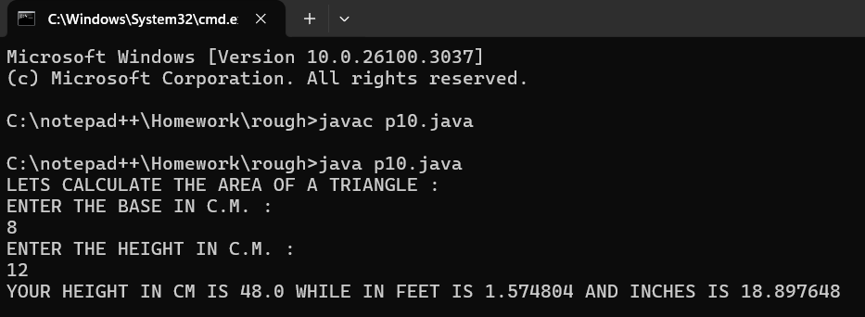

**PROGRAM – 3**

**Q3:** Write a program to find the side of the square whose parameter you read from user

**CODE:**

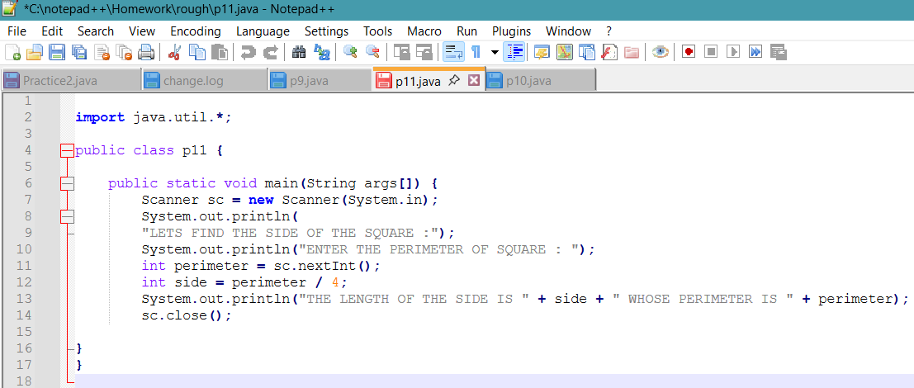

**OUTPUT:**

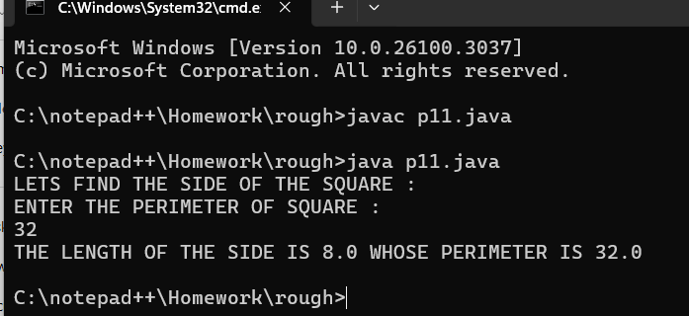

**PROGRAM – 4**

**Q4:** Write a program the find the distance in yards and miles for the distance provided by user in feet

**CODE:**

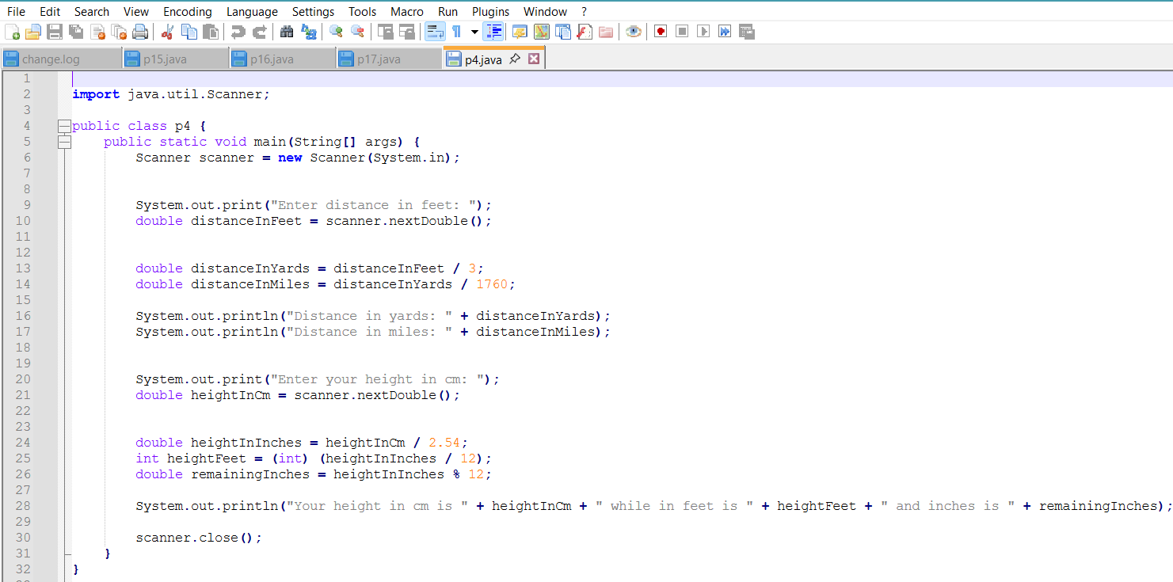

**OUTPUT:**

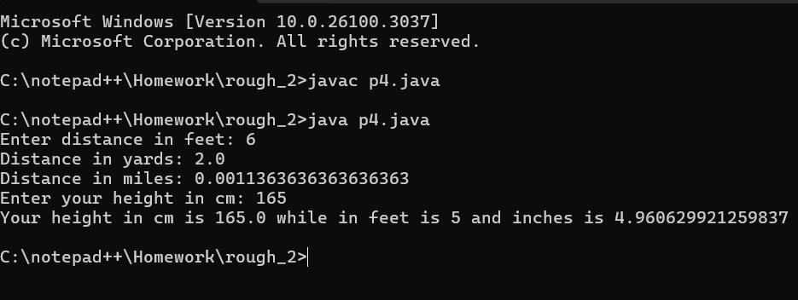

**PROGRAM – 5**

**Q5:** Write a program to input the unit price of an item and the quantity to be bought. Then, calculate the total price.

**CODE:**

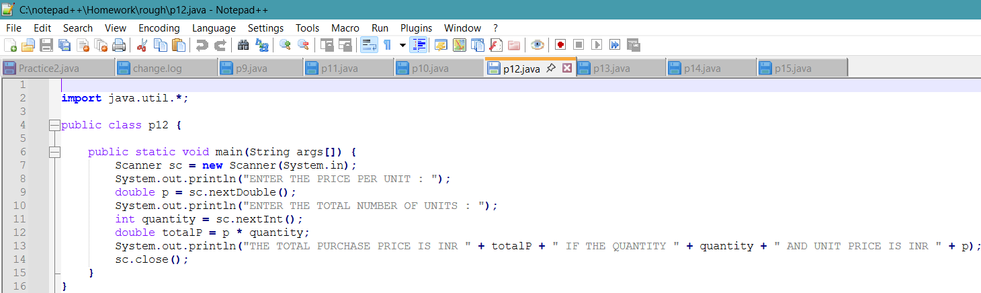

**OUTPUT:**

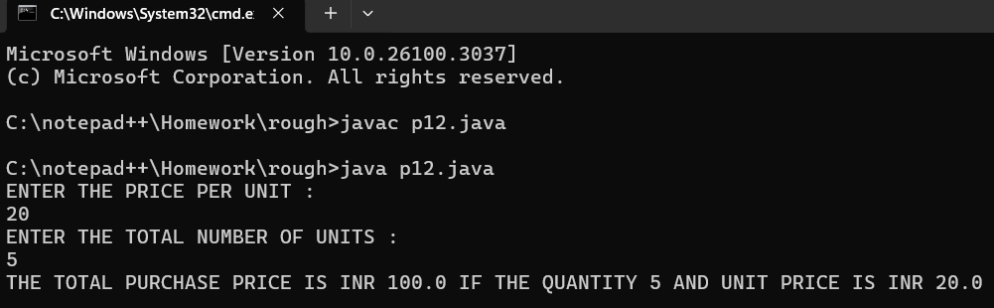

**PROGRAM – 6**

**Q6:** Write a program to take 2 numbers and print their quotient and reminder

**CODE:**

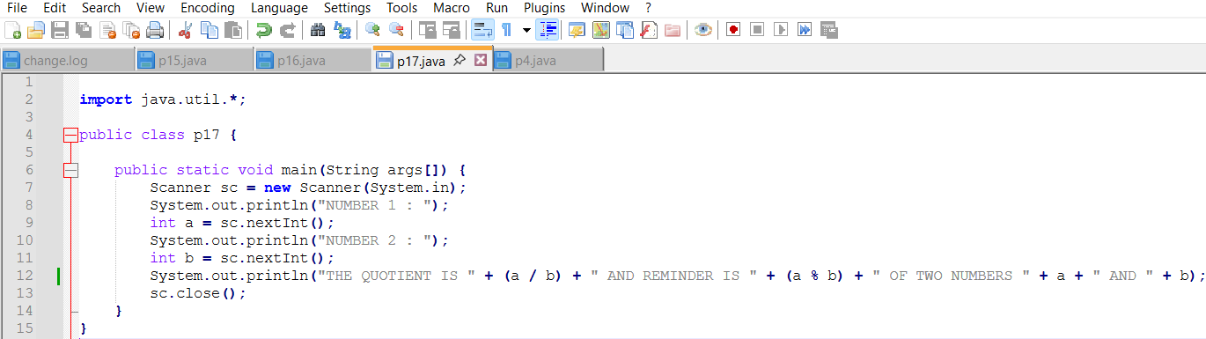

**OUTPUT:**

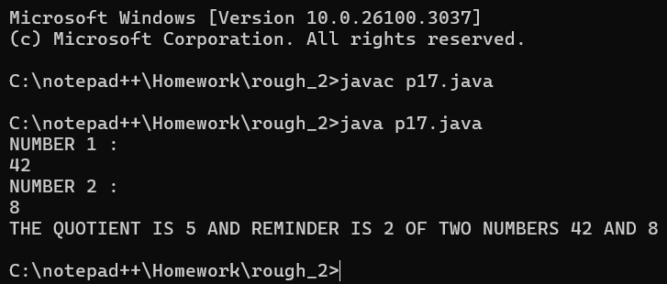

**PROGRAM – 7**

**Q7:** Write an ***IntOperation*** program by taking a, b, and c as input values and print the following integer operations a + b *c, a * b + c, c + a / b, and a % b + c. Please also understand the precedence of the operators.

**CODE:**

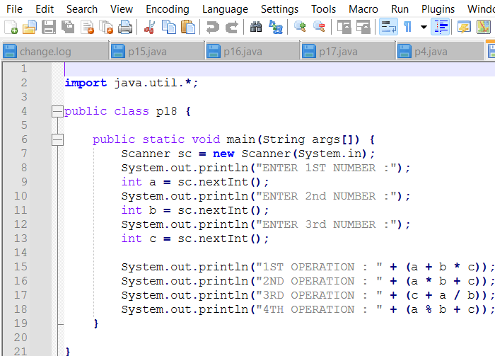

**OUTPUT:**

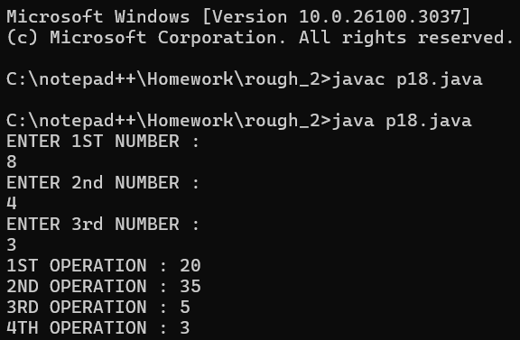

**PROGRAM – 8**

**Q8:** Similarly, write the *DoubleOpt* program by taking double values and doing the same operations.

**CODE:**

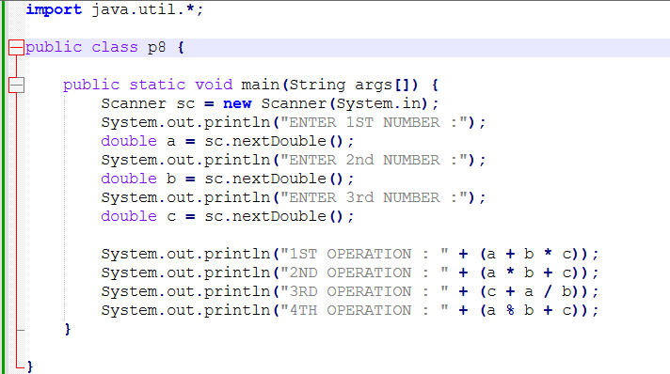

**OUTPUT:**

